Possible sequence of tasks for Year 1: Matches: “Here’s a school bus over here (child picks from 2-3 matching cards) … Points to: “where’s the school bus? Where’s the car…” Names: “What’s this?” Points to descriptor: “Which one says Choo Choo?”
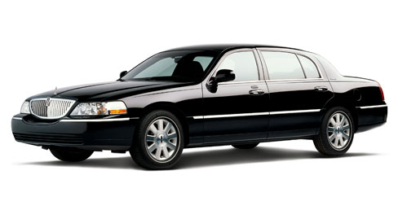
For Year 2: Names: “What vehicle is this?” Points to descriptor: “Which on flies in the sky?” Categorizes/Fills in the blank: “A school bus, a car, a train, an airplane. These are all ______” (vehicles) Reverse definition: “I’m thinking of a vehicle that is yellow. It takes kids to school. What is it?” (school bus)
