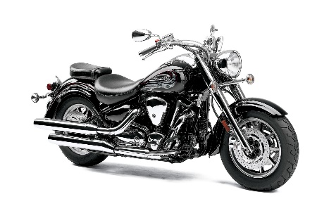
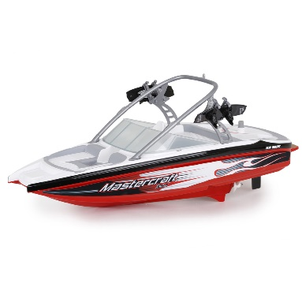
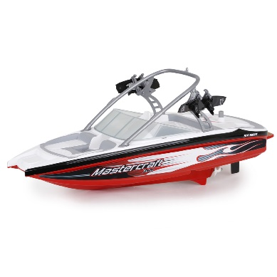
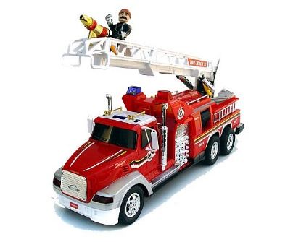
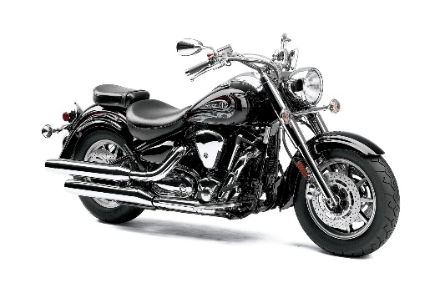
Use to test or teach answering “IDENTIFY” YES/NO questions. Start at the left and point to each picture. Model first to prevent errors. Have fun with it. Act like the “No” answers are silly. “Let’s find the motorboats!” Point and ask, “Is this a motorboat? No! Is this a motorboat? No? Is this a motorboat? Yes. Is this a motorboat? Yes. Is this a motorboat? No. Your turn.” Have the child do the whole line correctly if possible.

Use to test or teach answering “IDENTIFY” YES/NO questions. Start at the left and point to each picture. Model first to prevent errors. Have fun with it. Act like the “No” answers are silly. “Let’s find the motorboats!” Point and ask, “Is this a motorboat? No! Is this a motorboat? No? Is this a motorboat? Yes. Is this a motorboat? Yes. Is this a motorboat? No. Your turn.” Have the child do the whole line correctly if possible.

